WEEK 3 REPORT
Advanced Data Analysis and Visualization in Logistics
Logistics Data Analysis Project

Submitted by: Sarthak Manwatkar
Branch: Computer Science and Engineering
Week: 3
Topic: Advanced Data Analysis and Visualization in Logistics

1. Introduction
Logistics and delivery operations generate large amounts of data related to delivery time, distance, package weight, transportation cost, weather conditions, delivery partners, regions, and customer ratings. Analyzing this data can help organizations understand delivery performance and identify factors that contribute to delays and higher costs.
In this Week 3 task, advanced data analysis and visualization techniques were applied to a hypothetical logistics dataset containing 25,000 delivery records and 15 variables. Python was used to perform exploratory data analysis, calculate statistical measures, examine relationships between variables, and create visualizations.
The analysis focuses on important logistics performance indicators such as delivery time, expected delivery time, delivery cost, delay rate, and customer rating. Different factors, including delivery partners, weather conditions, regions, and delivery distance, were also analyzed to identify operational patterns.
The purpose of this analysis is to transform raw logistics data into meaningful information that can support better operational decisions, improve delivery efficiency, identify potential bottlenecks, and help logistics organizations develop data-driven strategies.

2. Objectives
The main objective of this task is to understand the performance of a logistics and delivery system by analyzing the available delivery data.
The specific objectives of this analysis are:
- To explore the logistics dataset and understand its important variables.
- To calculate basic statistical measures such as mean, median, minimum, maximum, and standard deviation.
- To study the distribution of delivery time, delivery cost, ratings, and delivery status.
- To compare the performance of different delivery partners and regions.
- To understand how weather conditions can affect delivery delays.
- To study the relationship between distance, delivery time, delivery cost, and delays.
- To create useful visualizations using Python to make the data easier to understand.
- To identify important findings that can help improve logistics operations.
- To suggest practical recommendations based on the results of the analysis.

3. Dataset Description
For this analysis, a logistics delivery dataset was used. The dataset contains 25,000 delivery records and 15 different variables. Each record represents information about a delivery.
The dataset contains details such as the delivery partner, package type, vehicle type, delivery mode, region, weather condition, distance, package weight, delivery time, expected delivery time, delay status, delivery status, customer rating, and delivery cost.
The main variables used during the analysis are shown below:
Variable | Description
delivery_id | Unique identification number of the delivery
delivery_partner | Name of the delivery service provider
package_type | Type of package being delivered
vehicle_type | Vehicle used for the delivery
delivery_mode | Mode of delivery
region | Region where the delivery took place
weather_condition | Weather condition during delivery
distance_km | Delivery distance in kilometres
package_weight_kg | Weight of the package
delivery_time_hours | Actual time taken for delivery
expected_time_hours | Expected delivery time
delayed | Indicates whether the delivery was delayed
delivery_status | Current status of the delivery
delivery_rating | Rating given for the delivery
delivery_cost | Cost associated with the delivery
The dataset was analyzed using Python and Pandas, while Matplotlib was used to create different visualizations. The analysis helped in understanding delivery performance and identifying factors related to delays, delivery time, and cost.

4. Data Preparation and Analysis Methodology
Before starting the analysis, the dataset was loaded into Python using the Pandas library. The dataset was first checked to understand its size, columns, data types, missing values, and duplicate records.
During the initial check, there were 25,000 records and 15 columns. No missing values were found and there were no complete duplicate rows.
The delivery_time_hours and expected_time_hours columns were originally stored in a timestamp-like format. These columns were converted into numerical hour values so that they could be used correctly for further analysis.
A numerical delay variable was also created from the delay status. This made it easier to calculate the overall delay rate and study the relationship between delays and other numerical variables.
After preparing the data, the following analysis was performed:
- Basic statistical analysis using mean, median, mode, minimum, maximum, and standard deviation.
- Distribution analysis of delivery time and delivery cost.
- Analysis of delivery status and customer ratings.
- Comparison of delivery partners based on delay rate, cost, delivery time, and rating.
- Analysis of weather conditions and their effect on delivery delays.
- Comparison of performance across different regions.
- Relationship analysis between distance, delivery time, and delivery cost.
- Correlation analysis between important numerical variables.
- Creation of charts using Matplotlib to make the results easier to understand.
The analysis was carried out using Python, Pandas, and Matplotlib.

5. Statistical Analysis
The first step of the analysis was to calculate basic statistical values for the main numerical variables. Mean, median, mode, minimum, maximum, and standard deviation were used to understand the general behaviour of the logistics data.
The analysis gave the following results:
Variable | Mean | Median | Minimum | Maximum
Distance (km) | 150.39 | 151.00 | 3.60 | 297.10
Package weight (kg) | 25.15 | 25.14 | 0.67 | 49.52
Delivery time (hours) | 6.25 | 6.00 | 0 | 19
Expected time (hours) | 13.11 | 8.00 | 2 | 24
Delivery rating | 3.67 | 4.00 | 1 | 5
Delivery cost | 864.94 | 867.54 | 95.67 | 1632.72
Interpretation
The average delivery distance was 150.39 km, while the average package weight was around 25.15 kg. The average actual delivery time was 6.25 hours, compared with an average expected time of 13.11 hours.
The average delivery rating was 3.67 out of 5, which shows that the overall ratings were reasonably positive, although there is still room for improvement.
The average delivery cost was 864.94. The cost varied considerably between deliveries, with values ranging from 95.67 to 1632.72.
Overall, these statistics give a basic understanding of the dataset and provide a starting point for the more detailed analysis performed later.

6. Distribution Analysis
After calculating the basic statistics, the next step was to understand how the values are distributed. Histograms were used for delivery time and delivery cost because they make it easier to see where most of the deliveries are concentrated.
6.1 Delivery Time Distribution
The delivery time distribution shows how long deliveries generally took. The average delivery time was 6.25 hours, while the median was 6 hours. The delivery times ranged from 0 to 19 hours.
Most deliveries were concentrated around the lower and middle range of delivery times. The chart also shows that some deliveries took considerably longer than the average. These higher delivery times may be related to factors such as longer distances, weather conditions, or delivery delays.

6.2 Delivery Cost Distribution
The delivery cost distribution shows the variation in cost among the 25,000 deliveries. The average delivery cost was 864.94, with costs ranging from 95.67 to 1632.72.
The wide range indicates that the cost was not the same for every delivery. Factors such as delivery distance and other operational conditions can contribute to this variation. Further analysis of the relationship between distance and cost is presented later in the report.

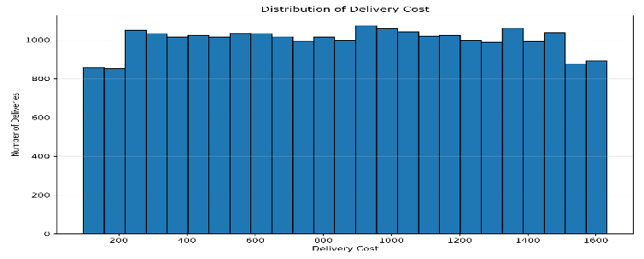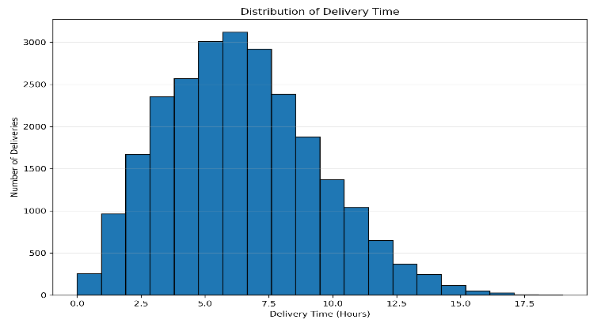
7. Delivery Status Analysis
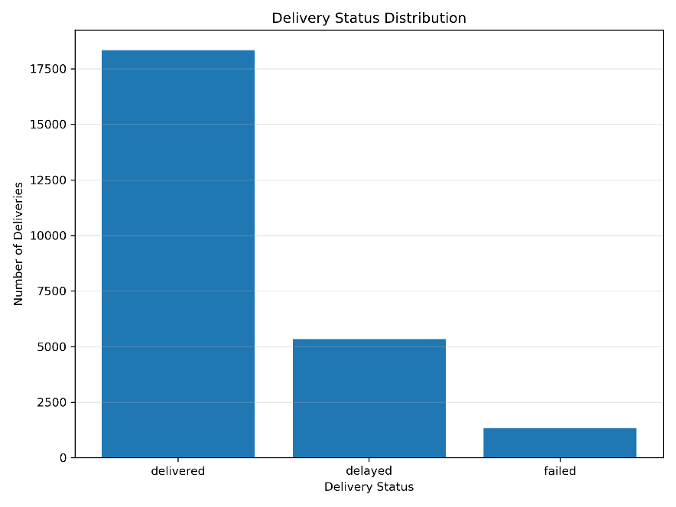
The delivery status chart shows the overall outcome of the deliveries in the dataset. The three main delivery statuses are delivered, delayed, and failed.
Out of the 25,000 deliveries, 18,331 were delivered, 5,341 were delayed, and 1,328 were failed. This shows that most of the deliveries were completed successfully, while a smaller portion experienced delays or failures.
The chart gives a quick overview of the overall delivery performance and helps identify the proportion of deliveries that may require further attention.

8. Delivery Partner Analysis
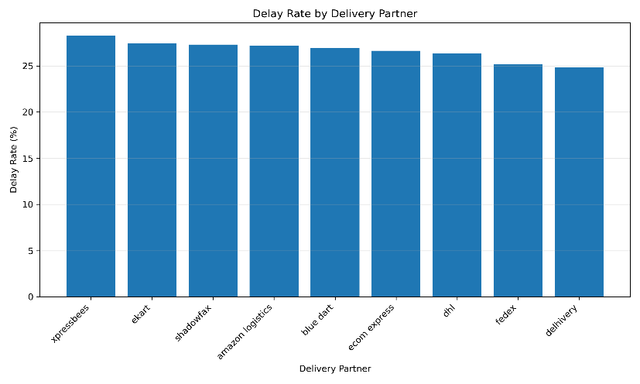
The delivery partners were compared based on their delay rates. The analysis shows that the delay rate was not exactly the same for all delivery partners.
Xpressbees had the highest delay rate at 28.27%, followed by Ekart at 27.42% and Shadowfax at 27.30%. On the other hand, Delhivery had the lowest delay rate at 24.80% among the partners included in the analysis.
The difference between the partners is not extremely large, but the comparison can still help identify which partners may need closer monitoring. Delivery partners with higher delay rates could be studied further to understand the operational reasons behind their delays.

9. Weather Condition Analysis
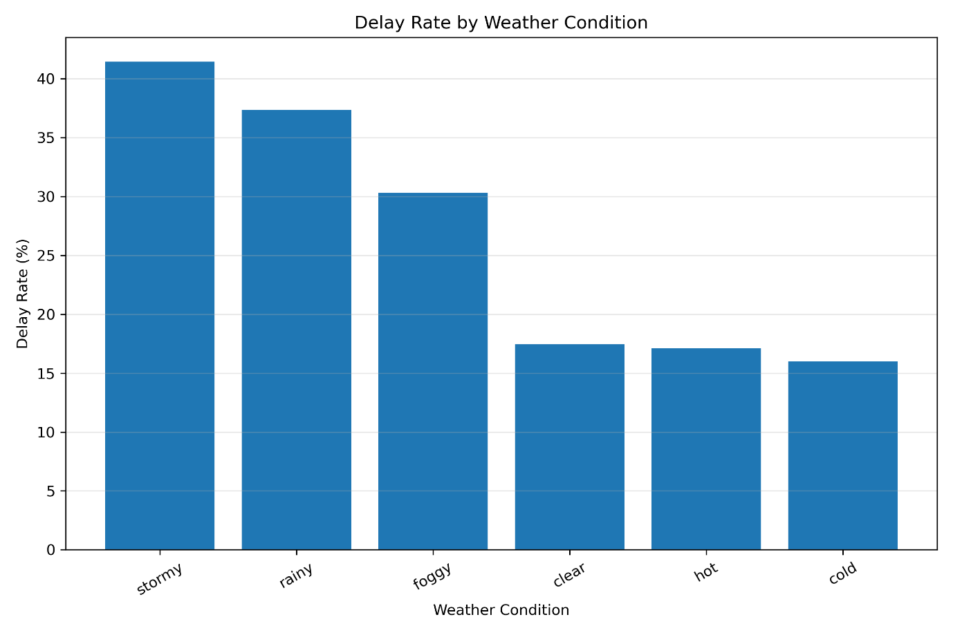The weather condition had a noticeable effect on delivery performance. Among the different weather conditions, stormy weather had the highest delay rate of 41.45%. Rainy weather also showed a relatively high delay rate of 37.35%.
In comparison, the delay rates during clear, hot, and cold weather were much lower, ranging from about 16% to 17%. Foggy conditions had a delay rate of 30.32%.
The average delivery time was also higher during stormy and rainy conditions. This suggests that difficult weather conditions can make transportation more challenging and may contribute to longer delivery times and delays.

10. Regional Performance Analysis
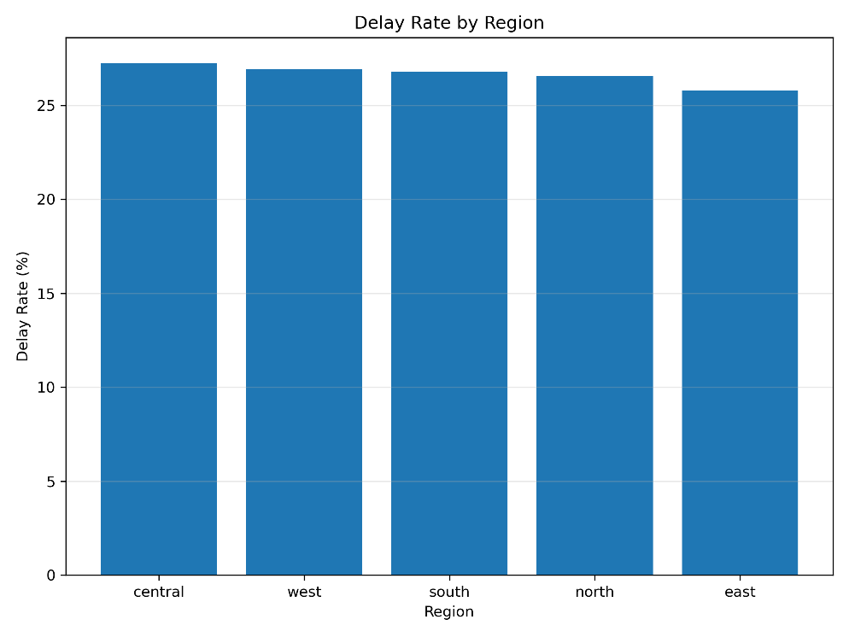
The delivery performance was also compared across different regions. The delay rates were fairly close to each other, but some differences can still be observed. The Central region had the highest delay rate at 27.25%, while the East region had the lowest delay rate at 25.80%.
The West region had a delay rate of 26.95%, followed by South at 26.78% and North at 26.57%. The average delivery times were also quite similar across the regions, ranging from 6.20 to 6.30 hours.
Overall, the regional differences were relatively small. This suggests that region alone may not explain most of the variation in delivery performance, so other factors such as weather, distance, and delivery partner should also be considered.

11. Distance vs Delivery Time
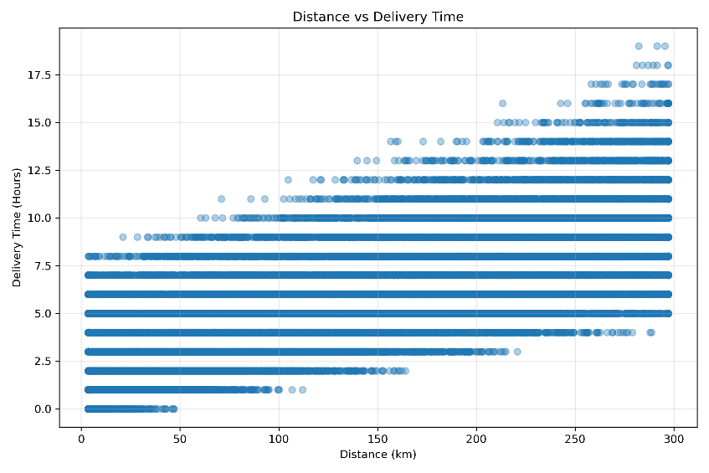
The relationship between delivery distance and delivery time was analyzed using a scatter plot. The correlation between the two variables was 0.69, which indicates a moderately strong positive relationship.
This means that deliveries covering longer distances generally tend to take more time. However, distance is not the only factor affecting delivery time, because some deliveries with similar distances can still have different delivery times.
This relationship is useful for logistics planning because delivery distance can be considered when estimating delivery times and planning transportation routes.

12. Distance vs Delivery Cost
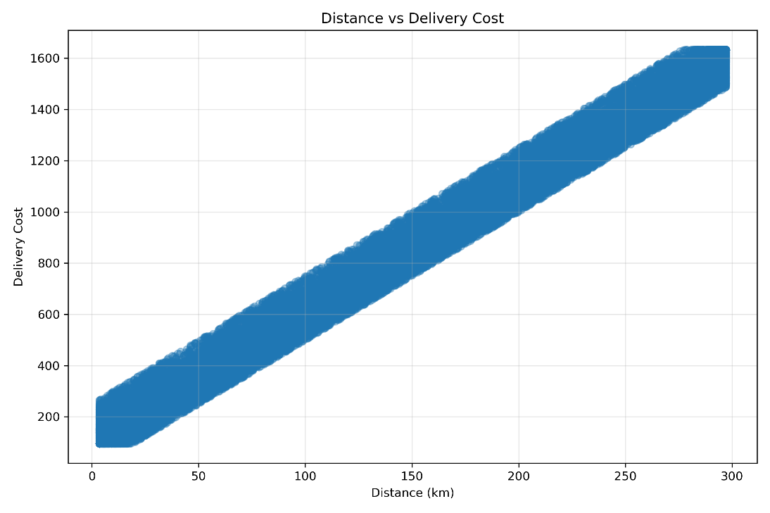
The relationship between delivery distance and delivery cost was analyzed using a scatter plot. The correlation between distance and delivery cost was 0.99, which shows a very strong positive relationship.
This means that as the delivery distance increases, the delivery cost also tends to increase. Among the variables analyzed, distance had the strongest relationship with delivery cost.
This finding is useful for logistics planning because distance can be considered when estimating transportation costs and planning delivery routes. It can also help in setting more suitable cost estimates for longer-distance deliveries.

13. Correlation Analysis
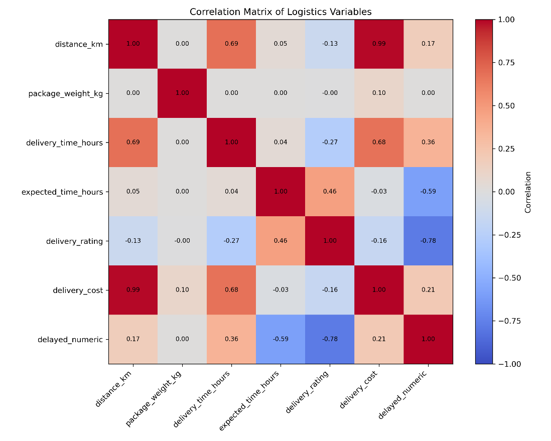
Correlation analysis was performed to understand the relationships between the main numerical variables in the dataset. The correlation values range from -1 to +1, where a value closer to +1 indicates a strong positive relationship and a value closer to -1 indicates a strong negative relationship.
The strongest relationship found was between distance and delivery cost, with a correlation of 0.99. Delivery distance and delivery time also showed a positive correlation of 0.69.
The correlation between delivery time and delay was 0.36, showing a moderate positive relationship. The strongest negative relationship was between delivery rating and delay, at -0.78. This suggests that delayed deliveries were generally associated with lower ratings in this dataset.
Overall, the correlation analysis helped identify which variables have stronger relationships and which factors may be useful for further logistics analysis.

14. Average Delivery Cost by Partner
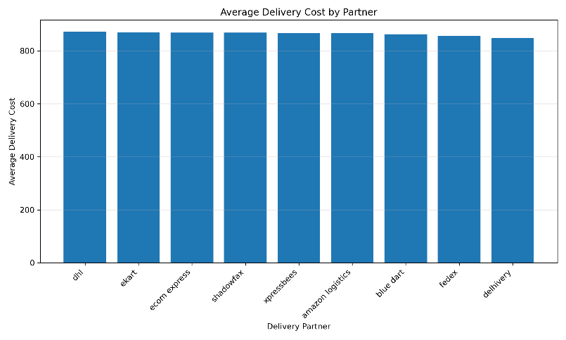
The average delivery cost was compared across the different delivery partners. DHL had the highest average delivery cost at 872.83, while Delhivery had the lowest average delivery cost at 848.11.
The difference in average cost between the partners is noticeable, although the reason for this difference cannot be determined from this analysis alone. Factors such as distance, vehicle type, package characteristics, and delivery mode may also influence the cost.
This comparison can help logistics managers monitor the cost performance of different delivery partners and investigate whether higher costs are justified by the services provided.

15. Delivery Rating Analysis
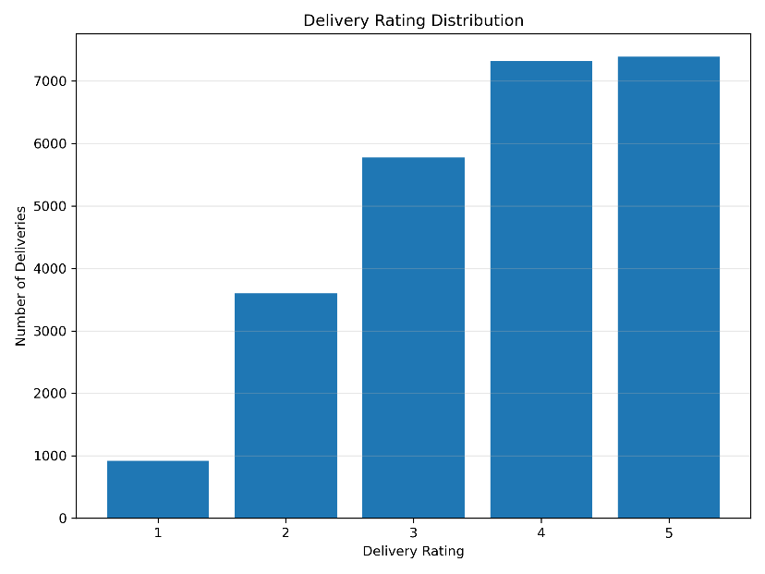
The delivery rating distribution was analyzed to understand how customers rated their delivery experience. The ratings range from 1 to 5, with an overall average rating of 3.67 and a median rating of 4.
The most common rating was 5, which indicates that a considerable number of deliveries received positive feedback. However, ratings from 1 to 4 were also present, showing that customer experiences were not the same for every delivery.
The rating analysis is useful because customer feedback can provide an additional measure of delivery performance. In this dataset, the correlation between delivery rating and delay was -0.78, indicating a strong negative relationship between the two variables

16. Key Analytical Findings
1. Overall delivery performance: The dataset contains 25,000 deliveries, with an average delivery time of 6.25 hours and an overall delay rate of 26.68%. This shows that delays are an important area to monitor.
2. Weather affects deliveries: Stormy weather had the highest delay rate at 41.45%, followed by rainy weather at 37.35%. Deliveries during these conditions also took longer on average.
3. Difference between delivery partners: Xpressbees had the highest delay rate at 28.27%, while Delhivery had the lowest at 24.80%. Although the difference is not very large, it can help identify partners that may need closer monitoring.
4. Distance is strongly related to cost: Distance and delivery cost had a correlation of 0.99, which was the strongest relationship found in the analysis. Longer delivery distances generally resulted in higher delivery costs.
5. Distance also affects delivery time: Distance and delivery time had a correlation of 0.69, suggesting that longer routes generally require more time.
6. Delays and customer ratings: Delivery rating had a correlation of -0.78 with delays. This indicates that deliveries marked as delayed were generally associated with lower customer ratings in this dataset.
7. Regional performance: The differences between regions were relatively small. Central had the highest delay rate at 27.25%, while East had the lowest at 25.80%.
8. Delivery cost differs by partner: DHL had the highest average delivery cost at 872.83, while Delhivery had the lowest at 848.11. Further analysis would be needed to understand why these costs differ.

17. Recommendations
Based on the analysis, the following improvements can be considered:
- Prepare for bad weather: Extra planning can be done during stormy and rainy conditions because they showed higher delay rates.
- Monitor delivery partners: Partners with higher delay rates can be reviewed regularly to identify possible operational problems.
- Improve route planning: Since distance has a strong relationship with both delivery time and cost, better route planning can help control time and expenses.
- Reduce delivery delays: Reducing delays can improve customer satisfaction because delayed deliveries were associated with lower ratings.
- Monitor delivery costs: Differences in partner costs should be reviewed to identify opportunities for better cost management.

18. Limitations

This analysis has some limitations. The dataset is hypothetical, so the results may not represent actual logistics operations. Also, the available variables do not provide detailed information about traffic, route conditions, fuel usage, or specific reasons for delivery delays. Therefore, the findings should mainly be used to understand the analytical process and identify possible patterns.

19. Conclusion

This analysis provided an overview of logistics delivery performance using Python-based data analysis and visualization. The study examined delivery time, cost, delays, weather conditions, regions, delivery partners, and customer ratings.
The analysis showed that weather conditions and delivery distance can have an important relationship with delivery performance. Distance had a particularly strong relationship with delivery cost, while delayed deliveries were associated with lower ratings. Overall, the visualizations made these patterns easier to understand and helped identify areas where logistics performance could be improved.

20. Tools and Technologies
The following tools and technologies were used for this analysis:
- Python – for data analysis and calculations.
- Pandas – for loading, cleaning, and analyzing the dataset.
- Matplotlib – for creating charts and visualizations.
- VS Code – for writing and running the Python program.
- Microsoft Word – for preparing the final report.

21. References

- Python Documentation – Python programming and data analysis concepts.
- Pandas Documentation – Data manipulation and analysis.
- Matplotlib Documentation – Data visualization and plotting.
- Logistics delivery dataset used for this internship project.

